|  |  |
| --- | --- |
| HUMAN COMPUTER INTERACTION  HCI | Abstract  To understand recent human computer interaction with related developments and their application  Mr. Thihan Hein  Level 5 HCI |

Contents

Evaluation of Tanks (1.1) 3

NORINCO Type 63 SPAAG 4

BNCFM SIBMAS 5

T-72B3 6

Impact of HCI in the Workplace (1.2) 6

Rescue 6

Bomb Finding 7

Emergency Bridge Construction 7

Transportation 8

Moving Anti-Aircraft Defense 8

Economy 9

How they tried for tank? 9

Types of Users and User Interface (2.1) 12

Driver 12

Shooter 12

Loader 12

Commander 12

Movement 13

Muzzle & Torrent 13

Control Direction 14

Human Memory 14

Driving 14

Speed Control 15

Get in a Tank 15

Knowledge Representation 16

Perception 16

Visual Perception 16

Movement 16

Hepatic Perception 16

Attention 17

Internal Attention 17

External Attention 17

Reasoning 18

Inductive Reasoning 18

Deductive reasoning 18

Abductive reasoning 18

GOMS 18

Goals 18

Operators 18

Methods 19

Selection 19

KLM 19

Ergonomics 19

Seat 20

Shocks In tank 20

Digital Technology 20

System Requirement 21

10 Heuristics Principles (M1) 21

Compare Product with Different Company (M2) 25

K-9 Thunder 155 MM Howitzer (Samsung) 26

TATA 155 MM Howitzer 27

Specification of TATA 155 MM Howitzer 27

Comparing Both Tank 27

D 1 28

Preparation & Problems 28

Research & Problems 29

Learnt form Research 30

D 2 31

Time Schedule 31

References Links 32

# Evaluation of Tanks (1.1)

In early days, around 15 AD. The world is developing and human brains are more special than the Stone Age. At that time their explorer mind is getting bigger and bigger. They want to find news things, they want to know the other land of culture. Their colonize mind over. But they know other land has other people. If the met they have to fight. Before AD 15 they use axe, spear, wood or iron shield and so on. After AD 15 AD, human brains are more develop and they decided to invent a weapon which can use without running attack like axe or spear. A weapon called rifle which made with wood. It use saltpeter to make explosive. It is the first gun of the world. They bring that file for their colonize.

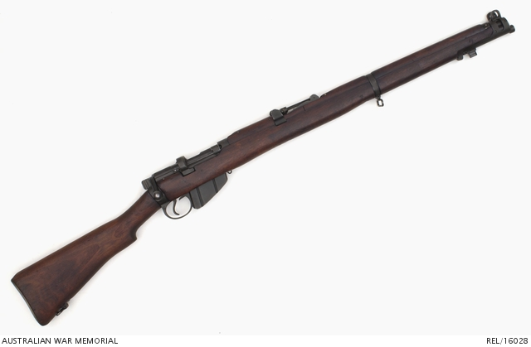

And human brains are still developing. They are not satisfy with that rifle because that is only have small explosive. They want more explosive. Around AD 16 they design and invent bigger gun called cannon. It can shoot more explosive than rifle. But it is bigger than rifle and difficult to carry and move. But they didn’t give up. They put wheel on that cannon and carry with donkey or horse. Because of their colonize and having that kind of weapon, war is appear and unfortunately two huge war is appear called World War I and World War II.

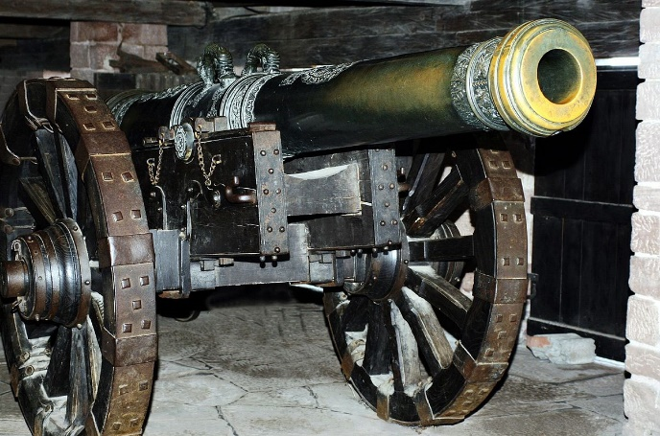

In WWI, they want to carry that cannon and they want a prevent form explosion. So they design and take a year to finish. At that time technologies are not develop. And they prototype, design and want to use inn WWI. But some of the design are not finish still though WWI finished. In WWI they invent a huge moving mobile with huge cannon and they called tanks.

Tanks are used to carry troop safety and to attack enemy base as a defense or far or near to the enemy base by using radar, high explosive ammos. Nowadays, tanks are more powerful and some tanks can go through in water. So it has many model evaluation through the years and years. So I want to evaluate tanks which changes in till 2018.

# NORINCO Type 63 SPAAG

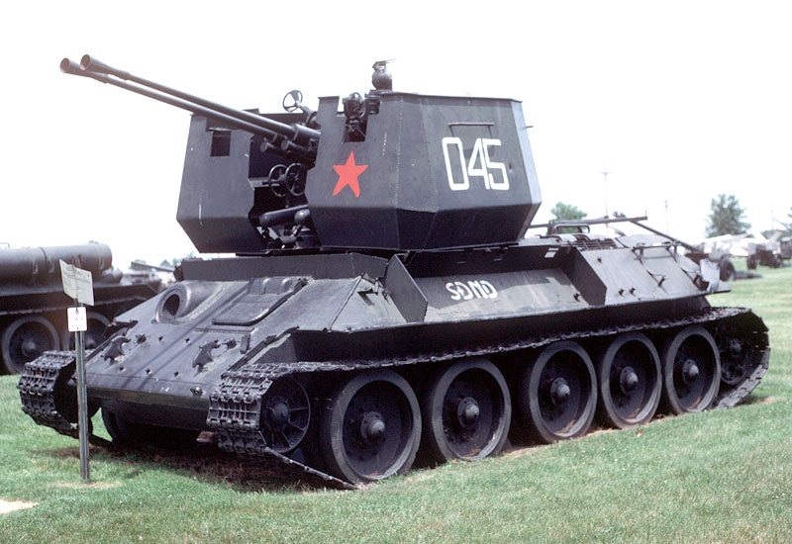

|  |  |
| --- | --- |
| Year | 1963 |
| Region | China |
| Total Crew | 4 |
| Length | 21 Feet |
| High | 9.8 Feet |
| Width | 9.8 Feet |
| Speed | 34 MPH |
| Engine | 1 x 12-cylinder turbocharged diesel engine developing 580 horsepower |

**History**

The design of the Type 63 is like a boxy, multi-faceted open topped torrent. The torrent featured full 360- degree rotation with limited traverse of the funds. This type of tanks is for the Anti-Aircraft Defense System. The weapon went on to see side scale use with many Soviet allies. Due to the using of 37mm shells and the repeat-firing, the weapon proved equally effective in the anti-armor role to a certain extent. A bow-mounted machine gun added limited anti-infantry defense. A standard crew is six personnel, including the driver and vehicle commander as well as gunners and loaders to manage the firing/reloading functions, were housed in the hull and turret. The cannons were fed via five-round clip containers which made reloading a regular process of the fast-firing guns. One limitation of this tank is engine is too loud and the speed is a little bit slow. So it can't go to the high. But it is mainly use not only in self air defense also use in ground hill defense.

# BNCFM SIBMAS

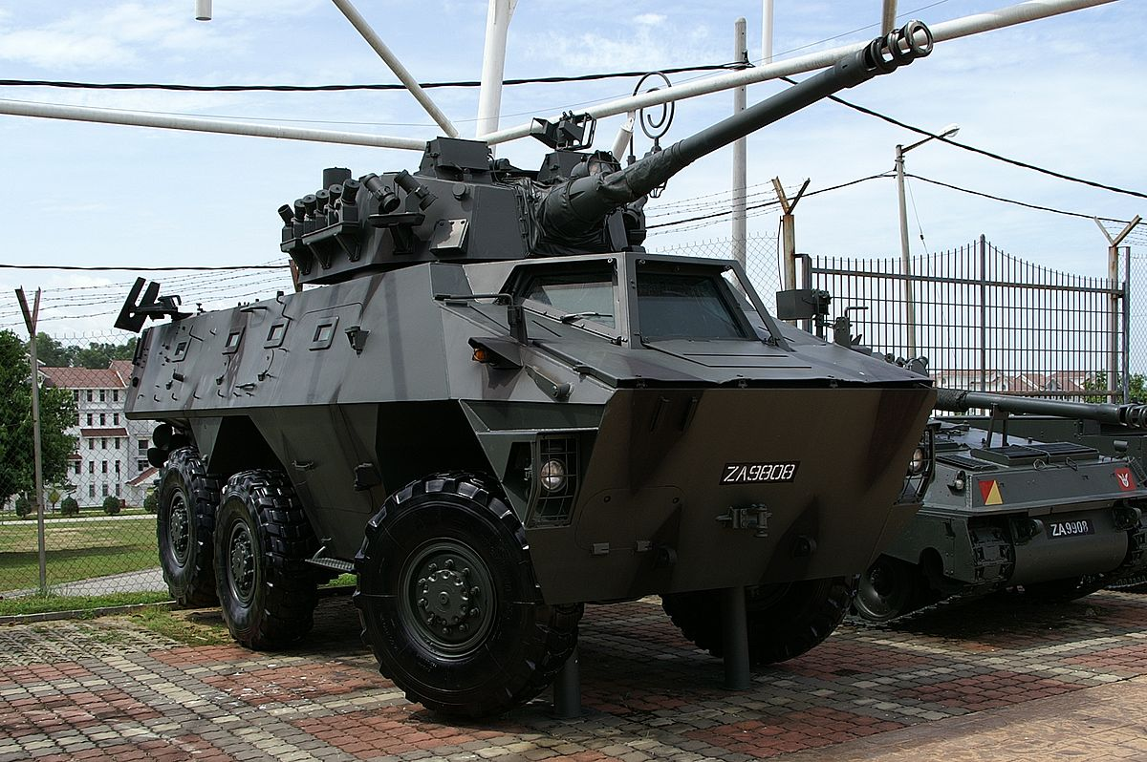

|  |  |
| --- | --- |
| Year | 1983 |
| Region | Belgium |
| Total Crew | 3 crew and troop |
| Length | 24 Feet |
| High | 8.20 Feet |
| Width | 9.09 Feet |
| Speed | 62 MPH |
| Engine | D2566 MK 6-cylinder diesel engine 320 horse power |

**History**

This type is 6 wheel armored vehicle with can access multi role battlefield. it can shoot both air and ground. That is called multi-role. And it is also a rescue vehicle include mortar carrier, cargo hauler, armored ambulance and armored command post vehicle. It use 6-cylinder engine with 320 horse power. So engine sound is quiet and fast enough. Wheel can access 6 wheel drive. And it has doors both side of the vehicle. Crew and passenger can get in car easily and door is as thick as other parts. So it can prevent form small explosive. Wheels are large and rubber tire. They can run in every condition except form sand. They can run on mud because it is 6 wheel drive. The high is excellent ground clearance and it can prevent from mines. At the time, shocks are used in tanks. So this type of tank use shock to prevent form jumping. And it torrent can turn 360 degree. And it can connect with radar for the air defense. It can tank out as a transportation vehicle because of the torrent is light and it has metal huge cover.

# T-72B3

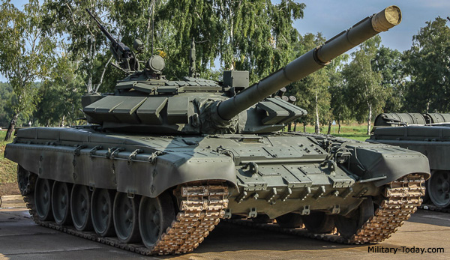

|  |  |
| --- | --- |
| Year | 2013 |
| Region | Russia |
| Total Crew | 3 |
| Length | 22 Feet |
| High | 7.2 Feet |
| Width | 11 Feet |
| Speed | 1130 MPH |
| Engine | V-92S2F diesel 12 Cylinder 620 horsepower |

**History**

This type of tank is form Russia main battle tank which is upgrade form T72B. The new engine, gunner sight and new fire control system are upgrade from T-72B tank. This tank armed has 125 mm and sub machine gun to defense air attack and ground. This type is also multi-role type. Because it's tunnel is for the ground. But it has sub machine gun both can shoot air and ground. And torrent autoloader and easy to use. And this tanks has digital technology. And use 12-cylinder with 620 horse power. So engine sound is quiet enough and can run 1130 MPH (Mile per Hour). They are now famous tanks and every country use as training or show. Because of its design and performance.

-------------------------------------------------------------------------------------------------------

# Impact of HCI in the Workplace (1.2)

Tanks are used in rescue, in battle, to breakthrough enemy base which are hard to attack and large enemy force. It can also use offensively and defensively since they are great mobility. Here is some impact of tanks that are used in workplace.

## Rescue

Some of the tanks are used for rescue such as in a danger place or enemy base. Some use in fire rescue to give medical safety. Because Tanks are use thick and huge metal, they can prevent from assault rifles and some sniper rifles. And some tanks can go through mud because of their big wheel and huge chain. So they can drive in every situation. Because having huge metal cover, they can go through and can rescue people or troop. In that tank it can have some medical care, and thick cover so it can avoid from explosive materials. Some of the tanks are used in fire rescue such as fire in wood. In fire wood, it is difficult to go through fallen and fire trees. So they use rescue tanks to go through to the fire trees and make less fire in the wood.

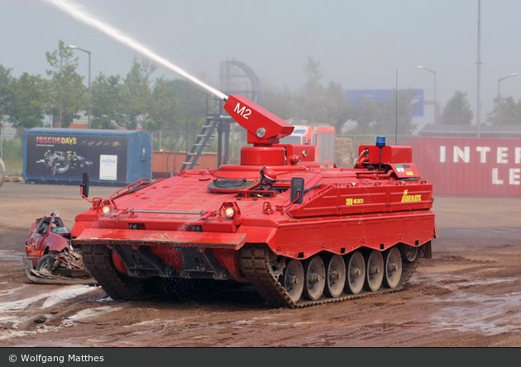 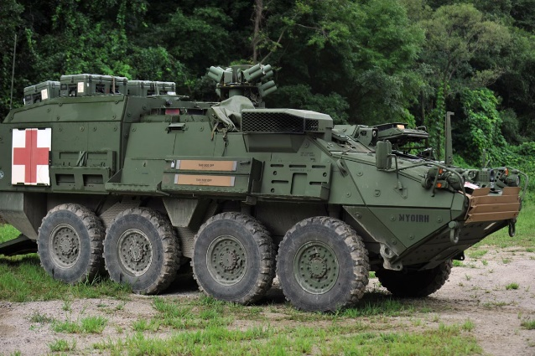

## Bomb Finding

Bomb finding also take out by tanks such as in the forest are high mountain which place couldn’t go by troop and difficult to take. In some condition like high explosive bomb disposal. So it can have less death. Instead of using human, it can cover human by using tanks. It is like a CAT heavy construction equipment. And they can endurance high explosive and they can dig like a CAT heavy machine.

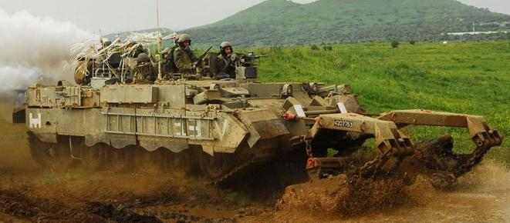

## Emergency Bridge Construction

In some condition, tanks can take out in emergency constructions such as bridge construction and so on. Mainly in bridge emergency construction. It can carry over 60 tan of materials such as vehicles, armored tanks and medical vehicles. It can have over 19 meter length. The big wheel and chain can help the bridge tank to go to the barriers conditions. It can use in the emergency bridge construction and it can use in battle. It’s floor is fast enough to split and make a bridge. It can only take only 10 minutes to finish and to start. So tanks are also use in the emergency bridge construction not only for battle but also for the public which are distrust by bad weather condition.

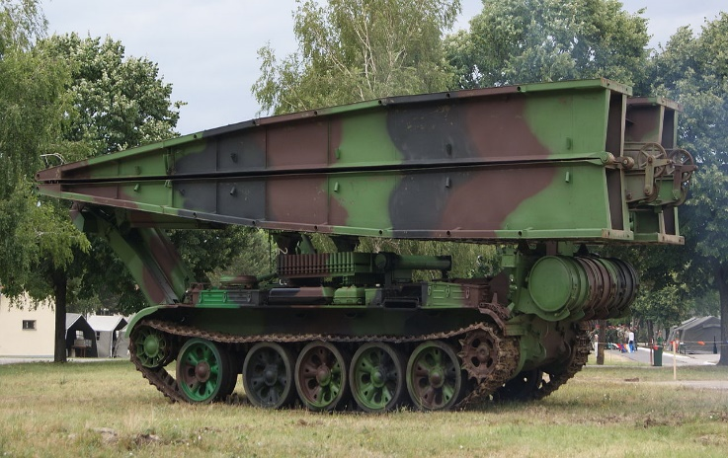 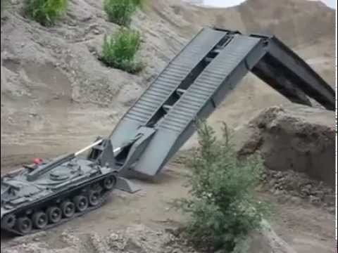

## Transportation

Tanks can also use as a transportation vehicle. Mostly use in S.W.A.T troop to carry safety one place to operation tasks. Unlike other tanks, transportation are fast and they can carry many weight on them. Because of having thick huge cover, it can prevent from penetrating form assault rifles and some snipers. So they can transport troop safety and they can carry many heavy things into them. Because of their big wheel, it can prevent from barriers. Transportation tanks are useful not only in swat but also in public. They use transport tanks in the battle field to take care troops and war victim safety. And transport important materials to the battle field.

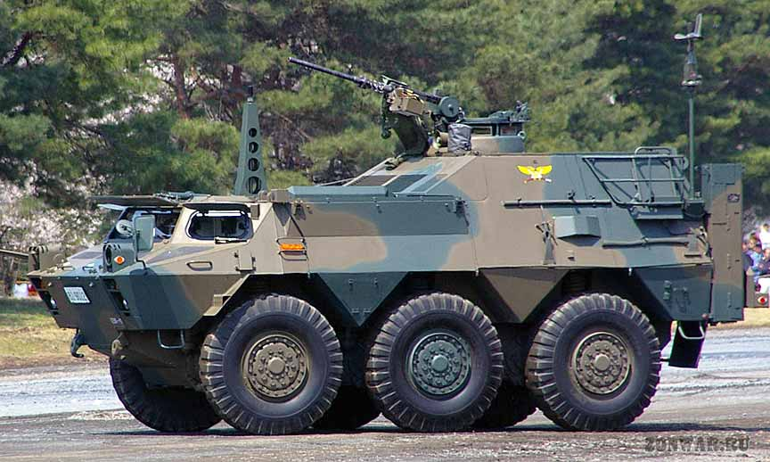 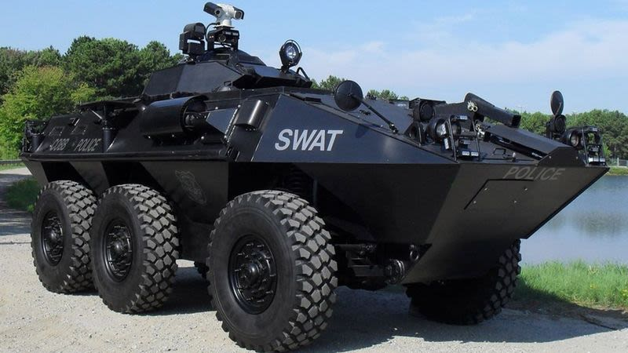

## Moving Anti-Aircraft Defense

Tanks are not only use in land, but also used to defense for the air region. But there are many missiles for air defense? So why does they need for moving anti-aircraft system. Answer is clear, air missiles are difficult to move. So they invent anti-aircraft defense. Anti-aircraft can defense enemy air planes by using small ammo. It can scare the air plane of the enemy. Because of fast reloading time and their thick cover, it is very powerful. Instead of using heavy missile, use anti-aircraft defense. They can easily move and they doesn’t take much space to place. And they can go every condition because of their wheel or chain. It can go through barriers and it can prevent form assault rifles.

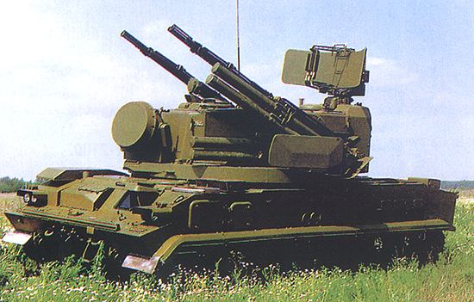

As a conclusion, Tanks are not only use in battle field environment. But also use in rescue, emergency construction they can help in public environments which are need by public. They are used as a transportation, rescue, bomb finding, and emergency construction and so on. In short they are not only use in military but also help in public environment for public areas.

# Economy

Tanks are help country economy in one part. So how they help country economy? So they are not only use in battle, but also use in economy. Some tanks are for sell such as T-72B3, air defenses, emergency bridge tank and so on. A tank can have over 6 million USD. So they can help country by selling them. Tanks can have both high price and low price. Developed country will buy high price tank and developing country will buy low price tank. It is depend on the model. Country such as USA, Russia, China, Turkey can sell most different type of tank and other country will buy from them. Here is some famous tanks that is best seller in this year.

|  |  |  |  |
| --- | --- | --- | --- |
| NO | Type | Price | Role |
| 1 | T-90 A | $300.000.000 | Multi-Role |
| 2 | T-90 S | $3.500.00000 | Multi-Role |
| 3 | Armata | 3.7 million | Multi-Role |
| 4 | Type 87 SPAAG anti-aircraft | 1.6 Million | Air defense |
| 5 | Tunguska-M1 | 2 million | Air defense |

# How they tried for tank?

Tanks are famous in World War I. In that face, tanks are more bigger than this days and less performance. But tanks are become a mainstay of ground battlefield armies. Britain, France and Germany find out ways to build a tank. They think about the basic principle such as armor, firepower and mobility of the tank. As an initial tank by Britain, named Little Willie which was constructed by William Foster Company. They design a tank and named Mark I and it was test by British Army. They spend over one year to finish first tank.

They use many works and many electronic, construction engineers, designer to make a tank. At that time, there is no technology like now a days. They use many iron materials to make body, and Chains are also made by hand. And they think about the where to place engine, because engine is too hot so and they find how to make cooling system. They tried many ways to put the torrent. Torrent can only use for front. They can't turn around. And the materials which tank use is too thick and heavy so engine is too slow. After one year later, Mark I tank is finish and tested by British Army. At that time, that kind of tank is very useful for attack and defense. In that one years, they face with many problems, lacking ironing. And the torrent. They also think about the control direction. Because that days was only cars and they have to think the control direction. And the petrol state. Tank need more petrol than the others. But there is no digital technology. If they want to shoot the look outside of the tank. They use, any handmade workers to finish a tank.

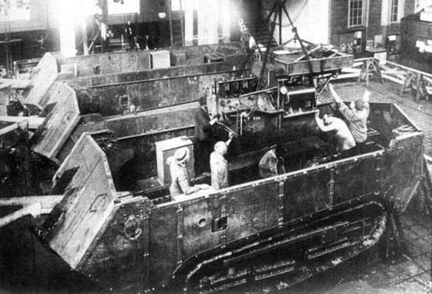

Tank construction

They tried many steps with several workers. They use handmade crane to carry heavy materials. Because there has no modern technology human only do all the work. Such as build a body, connect wire and so on. The problem is that they couldn’t finish in time all tanks. And they faced with the riot with the workers.

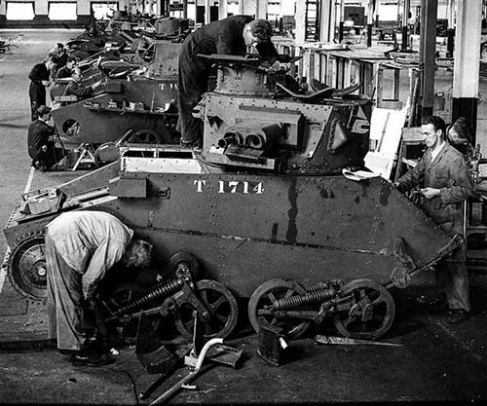

Build a tank without machine

Because of their power and policy workers can’t agree for over working. And country didn’t give worker salary enough and the economy of the country is very bad at that time. So sometimes lacking irons to continue build a tank. And workers also ran away from factory and other show their wish on the road. So riot appear and some of the tanks are doesn’t finish in WWI. Workers wants same freedom and they don’t want over working for that job even they didn’t give salary enough.

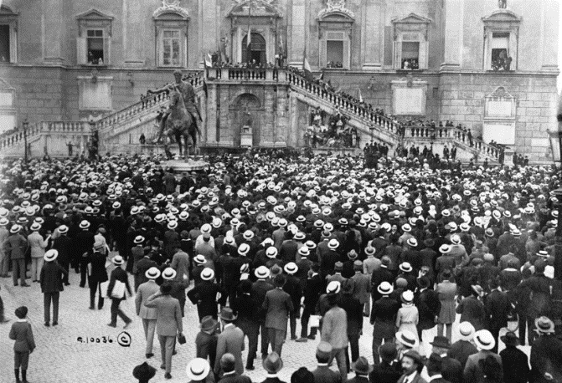

Workers riot

In 1914, WWI started. After finish WWI. They know how to modify for tanks and they invents crane and other machines that help to build tank. But one of the problem is that it is also need workers. One of the solution that they made is not to have over working for the workers. And if workers work in factory, they will have responsibility to have good attitude to workers like in lunch time, they will give lunch for workers. It is very effective way and the riot can reduce and tanks are finish in time before WWII.

In World War II They know about the fault and designs are very good and improved performance. In WWI some of the tanks are doesn’t finished in time because of the technology lacking of budget and materials. In WWI some technology are improved. Torrent can turn 360 degree and engine power also improved. And they finished all tanks in time for the battle. Before WWII Germany, France, British, Spain, China, Korea and many countries which take part in WWII already had tank industrials. And they invent rock, iron melting machine to get more materials for tanks. Designers, engineers are improve performance for tank. So these facts are the how they tried for tank. I hope you will understand of their work.

-------------------------------------------------------------------------------------------------------

Tanks are used in military base. Tanks are huge, thick, and use high explosive ammos. And they are one kind of moving vehicle. Now let’s learn how they work and their functions and features.

# Types of Users and User Interface (2.1)

Type of users is a user who will use tank. Tank are have in only military. So a user will be in military. So what type of military man will use tank. Not every military man use tank because they need some abilities to use tank. A tank can carry four crew. So let’s see what crew is it.

## Driver

Driver is to drive tank. A driver need driving abilities and he also need to know about the machine part of the tank for the emergency repairing tank. He will use tank for driving a tank. For emergency cases like fuse broken, wire broken, he should need to know about how to fix it. In battle, there is no garbage to fix it. So he should know about not only driving knowledge but also need to know about some machinery part of the tank.

## Shooter

Shooter is to shoot the target of the enemy. It abilities is to know about the mathematic to calculate distance, wind condition and the ground condition of the battle. Shooter need to shoot target exact and he need to get exact report and also reply exact report. And shooter shouldn’t wear glasses because glass can preventing to use lens. So shooter need to have good eyes to use lens and to calculate distance.

## Loader

Loader is to reload the ammo which has inside in the tank. It is mostly high explosive ammo. Another he is a helper of shooter. The ability is he need to concentrate for a condition. If the ammo are run out in the cannon, he need to refill faster and reply faster to all crew. And he need to have a strength to lift the ammos.

## Commander

Commander is a captain of a tank. Each tank have commanders. It is not a captain but it is a kind of captain rank while inside a tank. The rest crew obey what commander says. He also command for driving and shooting. He also calculate the distance to shoot by the commander and he need to reply faster and should make correct decision in a battle condition.

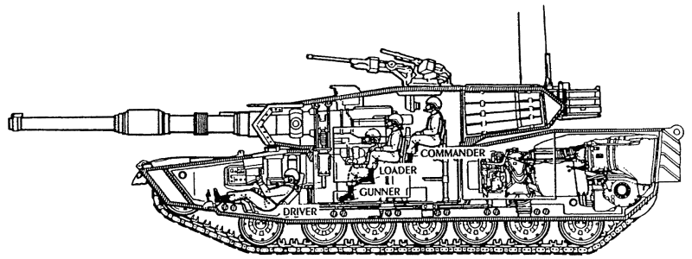

User interface mean the system interact between product and user. It can be design into an information with a user to interact. It can include the external parts of the feature which make a product seem famous. For example, in phone, it is flat, thin and use icons features. So in tank it has also features like, big wheel, torrent speed and so on.

Tanks are seems as huge metal box mobile. They can move and they can prevent from small explosive and prevent form every condition. Some tanks have torrent, machine guns, some are thick and so on. Now let’s start their interface.

## Movement

There are two types of movement in tanks one called with wheel and another is called chain. Wheels are not same as normal car wheel. Tanks wheels are very huge which is bigger than a normal car wheel. Because of thickness wheel, they can prevent from explosive bomb and barriers. And they can move whit speed. For chain, they are absolutely for sand condition. Because wheel can sinks in sand. But chain can prevent from sinking sands. Chain use gears to control direction and wheel are use steering wheel to control direction.

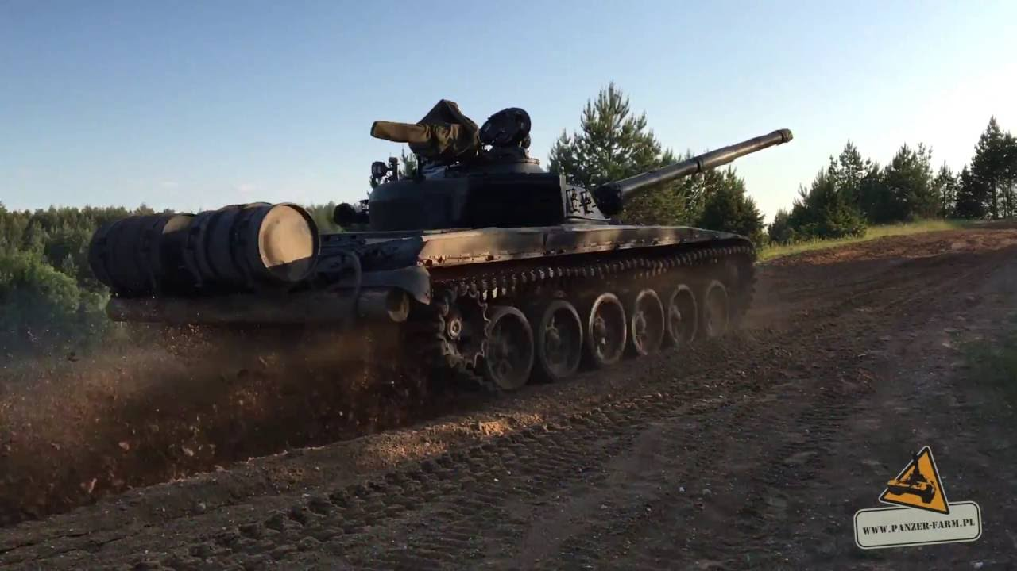 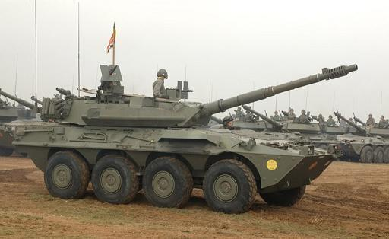

Chain and Wheel in a tank

## Muzzle & Torrent

In muzzle and torrent it has also two types called heavy, light and sub machine gun. Most of three type can turn 360 degree. It has auto reloading system. For heavy it use 120 mm ammo and light torrent use 152 mm ammos. They are use up to the condition. Some use only heavy but sometime use both light and heavy torrent in one tanks. By knowing torrent, we can easily know where they are used in. light torrent are used in air defense and heavy are used in ground battle field. Each torrent has sub machine gun.

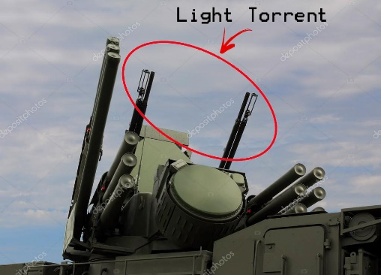 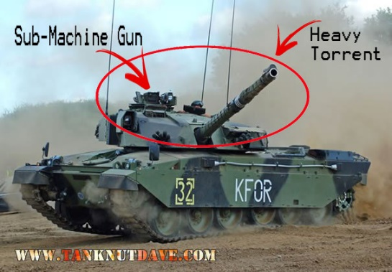

Light and Heavy Torrent

## Control Direction

It has also two type of control direction one with steering and another with gears. Both are control direction. But it has some differences. Steering need lever to speed up. But gear control can give it’s self and the speed can steady than lever. It’s control is easy to control but steering wheel need a little bit strength because of it’s big wheel. We can easily classified which type of use steering and which use gear. Wheel tanks use steering and chain tanks use gears. Because chain doesn’t have any axil to control it.

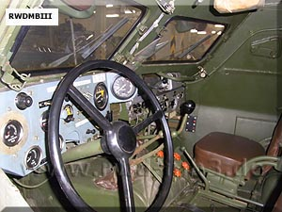 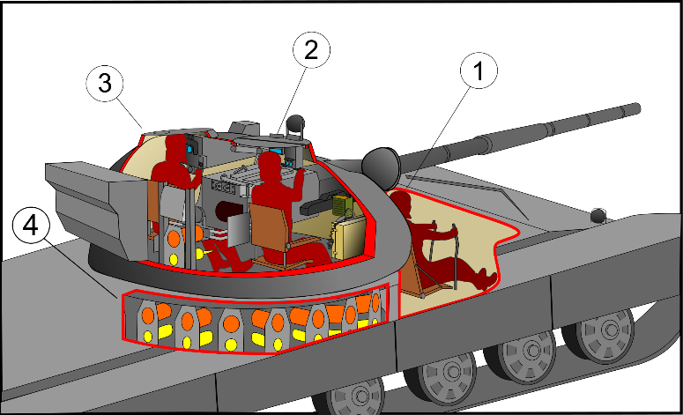

Sterring wheel and Gear Control Movement

Those are three user interface which can easily define for a tank and they seem made as a tank. I hope you will seem in your eyes.

# Human Memory

Human Memory is the study of a human with a behavior as an alternative behavioral approaches. It include some cognitive psychology. The processing which encodes input which had concentrate on a information and decide stores and retrieves from a memory and produce output as an action by deciding true or false.

For a human who will use tank will have some steps. To use tanks, a person need to know some steps which can make easily for a tanker. Tanks are easily to use because they are design for a tanker and for the battle. Now let’s see what human need to use a tank.

## Driving

As I says, tow type of driving control. So in driving a tanks they need to use memory. If a driver use steering tank, he need to know about the speed of lever. A driver need to push lever to speed and he need to what time will break and what time will do gear up or down. Both have sense of driving. They need to decide what driver should do in a short time. For example, while driving a tank , a driver see a barrier. A driver need to decide which way he turns. Or he go through? And he need to know the damage of barrier that can harm to tank. And he should decide the speed of a tank in a condition. In a normal condition how many speed will he use and in a battle, high hill or down of the hill.

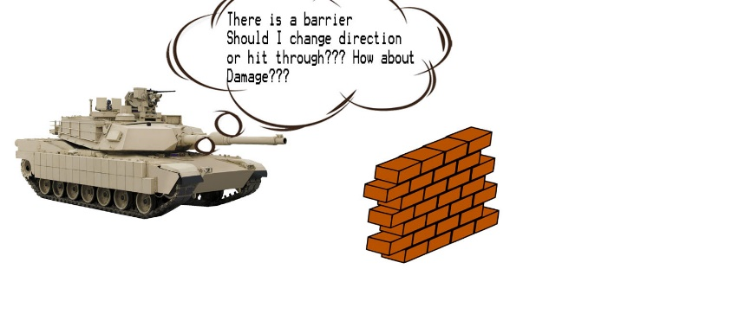

## Speed Control

Control Speed is also important for tank driver. So a lever is to speed up, break is to stop a vehicle and gear is to control the speed. Some of the tanks has auto gears some tanks manual. It is depend on their product years. If a tank is manual gear, a tank driver need to know the gear number of the tank and gear can control speed. A tank drive can’t drive with full speed as he want. He need to think about the crew and the road condition. He need to decide about the lever and break while driving.

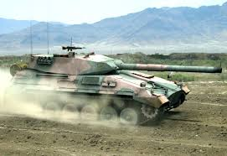

Tank driving with full speed

## Get in a Tank

A tank need three crew to drive. One is driver, shooter and command others. So how do they get in car? There is a technique to get in a tank. So a tank driver get in tank in front of the tank. Because the control are in front of the tank. A shooter and commander get in tank from side of the tank. Because it is different from the other normal vehicle. And there is no side doors in a tank.

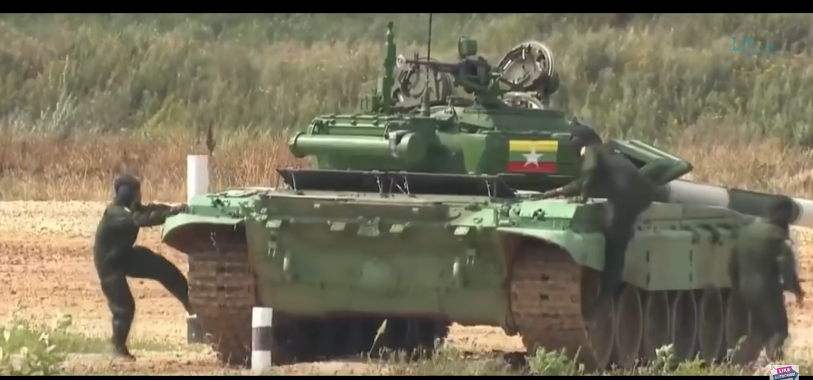

Get in tank from Side

# Knowledge Representation

Knowledge Representation is to know about the product as a profession. It is usually in a closed product. It include solving problem of the closed product and it can representation about the product. It also understanding about the framework useful for characterizing of the product.

How a tank make that seem a tank for a normal person? It is clear, a tunnel, chain, big wheel make a vehicle seem as a tank. And it’s has own represent colors. And the size of the tank.

## Perception

It is a kind of mental study technique which is the ability to seem hear or become to aware of something through senses. It is a kind of psychology. Another is a process by which individuals organize and interpret sensory impressions in order to give meaning to their environment. There are three types of perception.

## Visual Perception

Visual Perception is a sense that we can hear, see or touch a thing. And both sense we can know about the pattern of the product. We can know about the size of the product. And we can check the design and its touching feeling.

## Movement

It is the movement of the product. It include the direction and speed of the product which based on the visual perception.

## Hepatic Perception

It appear the feeling and reaching to the surface project. Haptic perception is the way person can gain information about the product by touching. It include the skin sensor and other parts of the body like muscle which recognize sensation such as pressure. Here is a tank that can have perception for a human.

|  |  |  |
| --- | --- | --- |
| No | Type of Perception | Description |
| 1 | Visual Perception | It seems a huge metal mobile which have a tunnel with big wheel or chain. It can shoot and can transport huge materials. Most of the colors are green, yellow and stripe colors. It is more than 15 feet and can carry 4 or 6 crew in a vehicle. The pattern of tank is shooting and transporting huge materials and troop. It can shoot light ammo or high explosive ammos. |
| 2 | Movement | A tank can move any direction by using wheel or chain. It use gears and steering wheel to control speed and direction. Mostly use 6 or 12 cylinder engine. |
| 3 | Hepatic | The feeling is that must be exciting for a normal and also for the crew. They can feel proud because of other people can’t ride or drive a tank. And most of the public have dream to drive a tank. |

## Attention

Attention is to get a respect or obey from the other by showing or giving product features. Two types of attention.

## Internal Attention

Internal attention is to attract a person without know the feature by a person. For example, as an internal attention for phone. We don’t know the model of RAM. We only know RAM 4,8 GB. We can’t know and didn’t get information of the model of RAM.

## External Attention

External attention is to attract a person with knowing features. It include the color, sound, voice and so on. As an example, the color of phone, or the design structure of phone can attract different people.

Here is some attention that make attract by tank.

|  |  |  |
| --- | --- | --- |
| No | Type of Attention | Description |
| 1 | Internal Attention | The engine and the shooting computer could make as an internal attention. Because of the engine sound is quite for a tank and it is fast than a person think. And shooting computer can calculate the distance meter of the enemy base. And it can aim the as lens. |
| 2 | External Attention | As an external Attention the color of the tank and the design of the tank. First color. Dark green, yellow and stripe are the attention of the tank and all person can seem bright in their eyes. And their tunnel. Tunnel can have different design, ground attack or air attack. Their tunnel can also attract for person to get in military. |

## Reasoning

Reasoning is to give a feedback for something. It can be good or bad. It is a kind of psychology that appear from public mind. It can be different. We can’t control them. It is a kind of decision and to give the output as a good or bad by human.

## Inductive Reasoning

It is a logical process with the multiple process. Each multiple process have true or false stages because it make decision in multiple condition. But both are combined to get a specific conclusion. It mostly include the measurement abilities like storm. It can help in work flexibility for unfamiliar information and to solve solution.

## Deductive reasoning

It is a logical process with a conclusion which based on the according of many process which are generally assumed to be correct. Sometimes it represent as a top-down logic. It is opposite of inductive reasoning. Deductive reasoning proceed form general to a specific conclusion.

## Abductive reasoning

This is also logical which is start with an observation or set of observation. After that it find the simplest and easy explanation which is powerful. This is different form the deductive reasoning.

Some people think tank is a killer for human but some people think it is need for the country. Both are true. We need to watch the condition that is happen in today. In Syria there has a battle between military and terrorist. Military use tank to attack for big enemy base not for the small. Military doesn’t want to hurt for military troops. So military use tank for big enemy base. But on the other hands, it shoot enemy base. The victim in terrorist area can harm about the shooting. That why some people think it killer for person.

And some people think because of having tank in terrorist area, that is why they can’t get peace. Tanks are heavy main battle vehicle they taught. And some people think tanks are not useful they can lost more fuel. But military doesn’t care about the bad voice form public. And they modified the old tank to get better performance.

## GOMS

GOMS stands for the Goals, Operators, Method and Selection. It is a part of the models of human performance which is used to improve the efficacy of the human and computer interaction with identify and eliminate unnecessary user actions. And it attempt the model and predict of user behavior. Each meaning (GOMS) has their represent facts.

## Goals

It is a task or something which a person want to do. For example, a person want to type, it is a goal for that person. Driving car is also goal. Goals is a kind of task that user want to make finish or not.

## Operators

To accomplish goals it need to use some input structure such as basic perceptual, cognitive, motor actions by user. For example, a person want to type, he need to give input key from keyboard. And when you drive you need a key to start the engine.

## Methods

Method is a kind of sub goals or sequence with combine with operators to accomplish a goal. For example, if you type a text, you need to open a software to type. If you want to drive a car you should know about the driving car. Method is a kind of way to take out the goal.

## Selection

Selection is a kind of rules that need to obey for a goal. And user need to follow in deciding what method to use in a circumstance. For example, you type text, rule is the size of text, justify and so on. And if you drive car, you should wear seat belt and drive normal. So selection is a rule that user need to follow and decide.

# KLM

KLM stands for the Keystroke-Level-Model. It appear after GOMS. But both KLM and GOMS are used together in HCI (Human Computer Interaction). It is the calculation with the number of steps with required to accurate and calculate overall task with the time to improve the quick for the end user. KLM based on time with a specific tasks which require as an average less than 5 minutes to complete all.

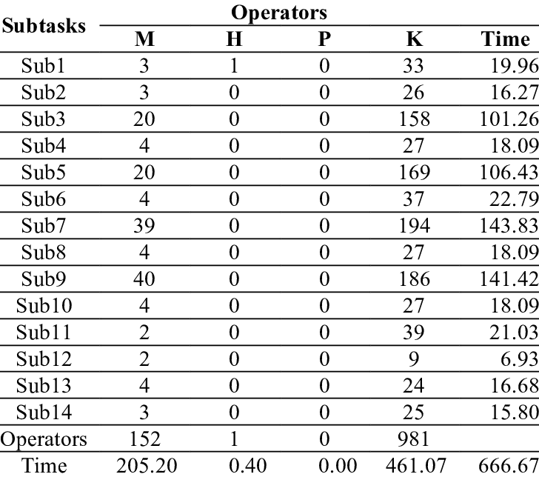

KLM-GOMS example

# Ergonomics

Ergonomics is the study of both physiological & psychological features between user, employee and company products. And it is learning of the people’s efficiency in their working environments. Physiological contain the physical body structure of the human body. And psychological include the mental part of the human. Purpose of ergonomics is to improve workspace that relate with an environment and to less risk or harm. By using technologies, theory, rules to make that materials which we use for work, use are design for a human body requirements.

In tank there is some ergonomic parts for a tanks users. In a tank it can have three or four tanker. So which part can have ergonomics for them?

## Seat

Seat can have ergonomics for driver and crew. Seat have cushion. So if a crew sit, it doesn’t harm bones and it can sit for long time because it’s east. But the differences is for the driver in chain tank. In chain tank the driver seat is difference. The seat is flat and the back is 75 degree line. So it’s shape is like a man line at 130 degree. But it is safe and it can drive for a long time and the circulation of blood is normal. And for the seat can adjust. It can place 90 degree or more than 90 degree. So if a crew is bored he can adjust the seat degree like normal cars. So seat is the first ergonomics things for crews and driver.



## Shocks In tank

Another ergonomic is the shocks in tanks. Unlike lay shock can prevent form jumping from bad road. Both shocks and lay are design to lift heavy metal. But disadvantages of lay is it can broke if it meth with heavy jump. And the fix cost is very huge and it can harm both vehicle and crew. The crew can jump in a car and they can’t handle their body. But shocks can prevent form jumping from high and prevent harm crew. Because shock can control itself. If a vehicle is jump from high the crew can control itself and doesn’t have much damage than the lay.

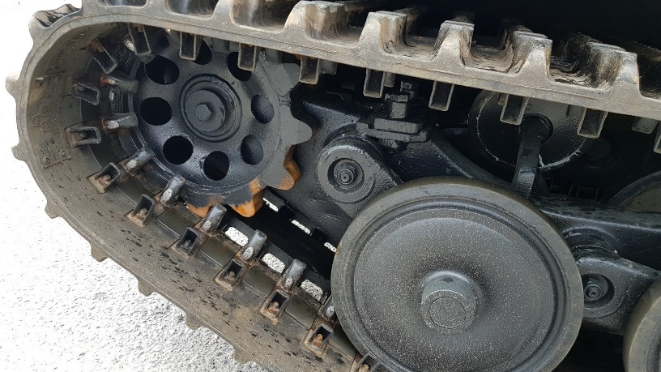

Shocks in tank

## Digital Technology

It is help in shooting. Instead of looking outside it can harm for shooter and even dead for crew. So digital technology can solve for herm to crew. Digital technology can detect the enemy base meter. So it can shoot inside vehicle. And it has auto reloading system. So it can reduce reloaded crew. So those parts make tank ergonomics for the crews.

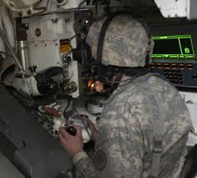

Digital lens in tank

# System Requirement

Here is some system requirement for a tank.

|  |  |  |
| --- | --- | --- |
| No | Type OF requirement | Description |
| 1 | Engine with 6 or 12 cylinder | Engine is the life of a vehicle. To control speed, direction and the power of vehicle is given by engine. |
| 2 | Wheel or chain | To move the vehicle |
| 3 | Tunnel and light guns | To shoot high explosive and defense air |
| 4 | Gear and steering wheel | To control direction and speed |
| 5 | Fuel | To power up the engine |
| 6 | Digital Technology | To connect with base and to measure the distance and shoot |
| 8 | Axil and shocks | To join wheel or chain and make soft jump with shocks |
| 9 | Key | To start up engine |
| 10 | Metal | To make body and cover of the tank |
| 11 | Gears | To control direction or speed |

Those are the types of HCI for a tank. I hope you should know about tanks.

-------------------------------------------------------------------------------------------------------

# 10 Heuristics Principles (M1)

Heuristics Principles is a mental shortcuts which let on a person to know and solve problem with the computer system and to make decision quickly with efficiently. It can make short decision with powerful without stopping constant to thin about their next action. Heuristics Principles helps people in many ways but they can also lead to cognitive biases. Here is 10 types of Heuristics Principles.

1. Visibility of System Status

It means a system should give the processing information to user with words, text, and number with user interface within reasonable time. For example, downloading rate from your browser. If the downloading rate doesn't show as a status, can user know easily? So to know the back end processing with user interface to end user is called visibility of system status.

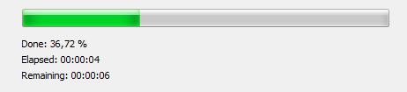

This Law is applied to tank vehicle. It apply the value of speed with number with a clock hand to know a tank driver how the speed is going. If the driver push lever slowly engine sound will quite. If push hard engine will high. But driver doesn’t know the speed by listening sound. And engine use 6 or 12 cylinder to reduce engine sound. So he doesn’t know the speed. So to know a driver how tank has speed and appear an interface called speedometer. Speedometer can show digits how speed is going to the driver. So driver can know easily the speed of the tank.

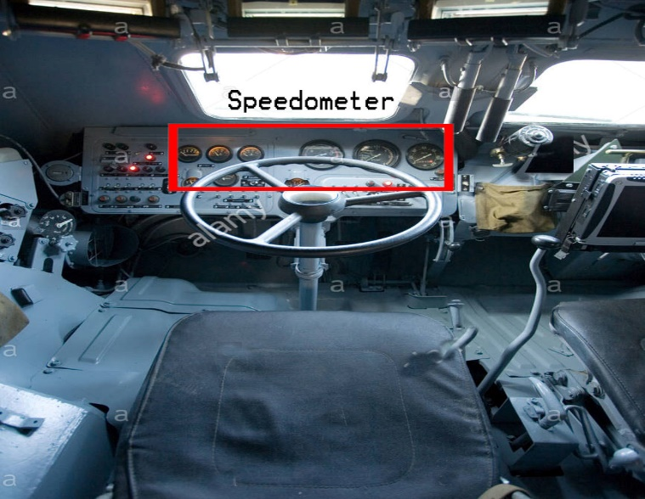

1. Match Between System and Real World

It means the design interface is should same with the real world objects. Some of the system parts can't talk to user with text, words and numbers. So at this time a interface is used called icon. That icon interface should same with the real world materials. But a real world material must be standard. Without standard, a designer difficult to know for the system. For example, a standard pencil interface in real-world is a sharp in top and a small eraser has on the back of the pencil. So in Microsoft paint, it has drawing pencil interface. That interface is same with real world pencil.

1. User Control and Freedom

This rule for mistake which user make wrong. Sometimes user can make mistake and that mistake need to solve. If the mistake is made. A user need to quick or switch off quickly by finding emergency exit. For example in Microsoft word document, a user typing and make mistake. So he only need to press backspace quickly. If backspace is over, he can recall undo called control + z.

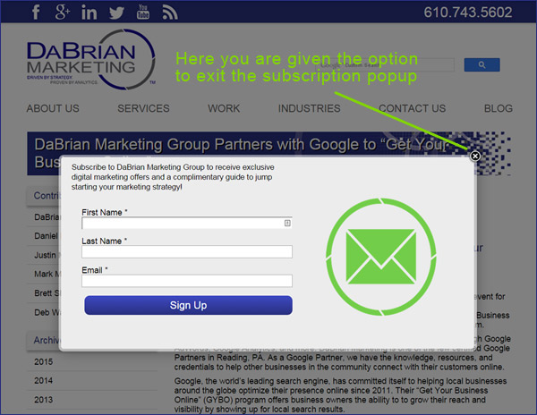

This Law is also applied to tank. This rule is applied in all type of tanks. The control system is freedom. If a driver want to drive it only need to push lever and push break to slow down a tank. If he need to change gear, he need to only push club to change gear. That is for the tank which with wheel. For chain tank, it only have two gears. Break is on the hand. And it can have emergency case. if the tank is drive with full speed suddenly a break doesn’t work. So a driver can stop a tank easily by pulling hand break. So it can have safety for driver and crew and he can control direction easily.

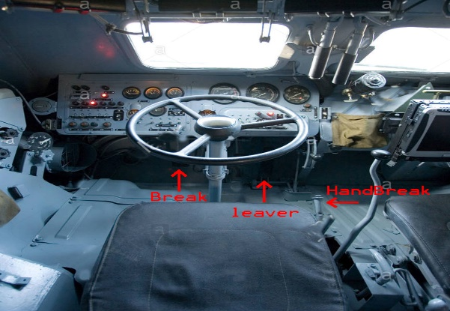

1. Consistency and standards

This is for the product and company. They should obey the standard rules. If the doesn't obey standard rules, it can difficult to use for the user. For example, the switch board. They only one two or three pins. That is the standard rule of IEEE. It can bring to any country and can use easily. If the doesn't obey that standard rule, it is difficult to use like Apple Products.

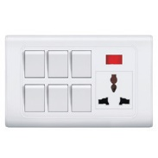

1. Error Prevention

A user should know about the processing of a system. A end user can't know the processing. And he doesn't know about the mistake that the do. So to understand about the mistake that user did, a dialog or interface should show called error prevention. User doesn't understand the processing. For example, in car, if the engine oil is low, the engine sound change. So user doesn't care about it. But if an system show a sound with interface to care about engine oil low, he can easily know.

1. Recognition rather than recall

This is a rule for the human memory which up to the product. User should have to remember all steps for a system. A product should have less human memory. If the steps are too much for user, he can disappointing for using that product. A product should be easy to use without having too much steps for user. For example, finger print system in Samsung Note 4 and Note 8. Note 4 finger print system is pull down thumb to the sensor. But in Note 8 it only have to put on the sensor. This rule is to make user easily without having many steps.

This rule also apply in tank for driving, shooting and reloading case. For driving he only need a key to start up engine. He only need to know the lever, break, and club for control speed. If he know that three control unit, he can drive a tank. For the shooter, he only need to know about the distance and only good to use the lens to aim and shoot the target correctly. And loader need to know how many ammo have in the torrent and if the ammo are run out he need to only reload. So tasks in tank are so simple, a driver need to know the control, shooter should know the distance and use lens and loader know the ammo which have in the cannon.

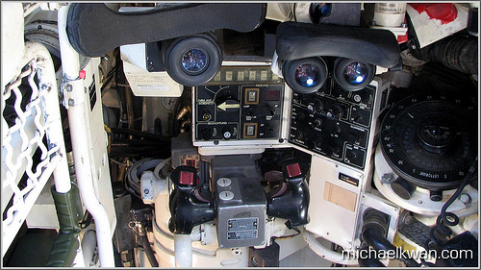

Distance lens, command and reload system

1. Flexibility and efficiency of use

A system or product should have the good efficiency of using for both inexperienced and experienced users. A product will use both inexperienced and experienced user. This rule is especially inexperienced user. For them a system should difficult to use. So how will you solve it? So the efficiency of se is for both inexperienced and experienced person.

1. Aesthetic and minimalist design

Dialogues should not contain too much information. You should decide which information is to show to user. With too information, user can't understand and they don't want to take out. Every system parts have related dialogues. For example, an error of the web site because of connection a user can't get into website. So a web browser just only show connection time out error and some notes to take out. if not all the information are full with in connection like 404 not found, user will difficult to decide and he will disappointed of using that browser.

1. Help users recognize, diagnose, and recover from errors

This is for user to under what error is it. User doesn't understand about the processing error. So to understand that error, a system should have a clear understand error message for user. If a user know about the error, he can make a decision with suggest solution.

It also apply in tank project. Tank need petrol to give energy to engine. So a tank can store about 37 gallons in an oil tank. If tank use oil can use as energy and produce as smoke. So if the petrol is low can a driver or crew know exactly? No it is difficult to find out how may petrol have in tank. It is not possible to watch to the oil tank. So to make measurement for oil an interface appear called oil meter. Oil meter can measure the rest of the petrol in the oil tank and show driver with number.

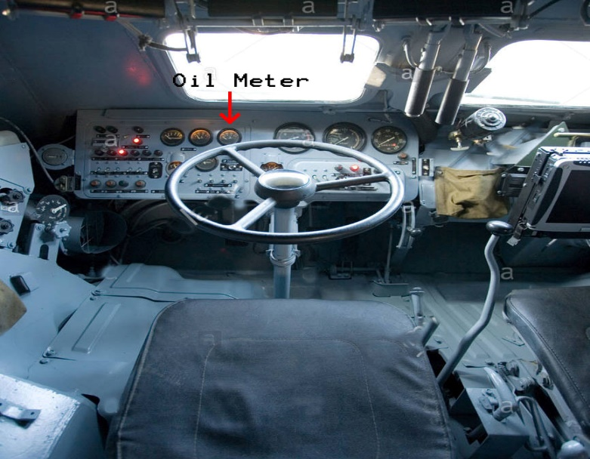

1. Help and documentation

It is to know about the whole system how working. It include testing, validation, verification, user guide and so on. It need because fora user to know how system working. If not user can't know the data validation, and he will miss some parts of the system. It can help not only for user but also help in further development to identify bugs and old function.

As a conclusion, this law apply four laws (Help users recognize, diagnose, and recover from errors, Recognition rather than recall, User Control and Freedom, Visibility of System Status) which are apply in control speed, direction and shooting case. The meter of speed, the distance of the shooting, reloading alert and the oil tank meter. It not tank users can’t know easily the problem that appear with engine, oil and shooting. So I hope you will know about this for laws with tank.

-------------------------------------------------------------------------------------------------------

# Compare Product with Different Company (M2)

We already know that Samsung Company is produce electronic devices like phones, laptops, wash machine, TV and many electronic devices. Samsung is a South Korea in Seoul. But one things we doesn’t know about Samsung. Did you also know that Samsung produce tank vehicle for South Korea Military? Yes, Samsung work for military as a business point of view and some political view.

Another Company which is work in both business and military in India called TATA Group. TATA is very famous car Production Company in India. It also produce tank and small vehicle for India military and for business. And it was also very famous in South East Asia including Myanmar, Indonesia, Philippine and also include China. So let’s see a product of tank that was produce by both company.

## K-9 Thunder 155 MM Howitzer (Samsung)

K9 Thunder is produced by 1999 by Samsung for the Republic of Korea Armed Forces. It use Chain and heavy torrent by using 155 Millimeter and 52 caliber gun. This tank is design for the high hill with shoot and scoot. It can shoot High Explosive with the auto reloading. The body is big like main battle tank. But it is thicker than other main battle tank. Because it designed to shoot with steady and to support air and ground units. And engine is MTU Friedrichshafen 8 cylinder diesel engine with 1000hp and speed is 67 kilometer per hour. But this tank seem a little speed slow and it has recoil when shooting. It can vibrate when shoot. So target can miss some meter but the body is very huge, it can prevent form sniper and refile ammo.

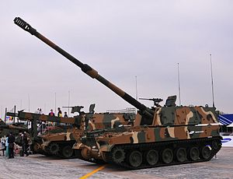

K-9 Thunder 155 M Howitzer (Samsung)

Here is the link of K9 Thunder which was created by Samsung.

(<https://en.wikipedia.org/wiki/K9_Thunder>)

Specifications of K-9 Thunder

|  |  |
| --- | --- |
| Year | 1999 |
| Total Crew | 4 |
| Length | 39 feet |
| Width | 11 feet |
| Height | 8 feet |
| Speed | 67 Kmh |
| Engine | MTU Friedrichshafen 8 cylinder diesel engine with 1000hp |

## TATA 155 MM Howitzer

It also use 155 MM 52 sub machine gun with different from chin. It use eight wheeled truck to enhanced movement. The gun was design from Strategic Electronic Division (SED) from TATA Company. The 155 MM can shoot six ammo in per time. It is design from M777 howitzer. But M777 tank time to move one to another. So TATA howitzer is seem that M777 is place on big truck. It is not really but the sense can think. It can control both human can computer. The computer system is in the head of the truck. The reloading time can take about a minute. It use bullet proof glasses and huge metal for head. but the back can not clear for sniper. But one of the purpose is to fire and less reloading time. And also has the movement. It need a time to prepare to shoot. Because it can vibrate when shoot. So truck can turn down to ground. To prevent that problem it hold with three ground holder which attached to truck. Those holder can prevent from overturn and it can less vibrate when shoot. Those holder are control by computer system and it need clearance ground to place. If not it doesn't useful.

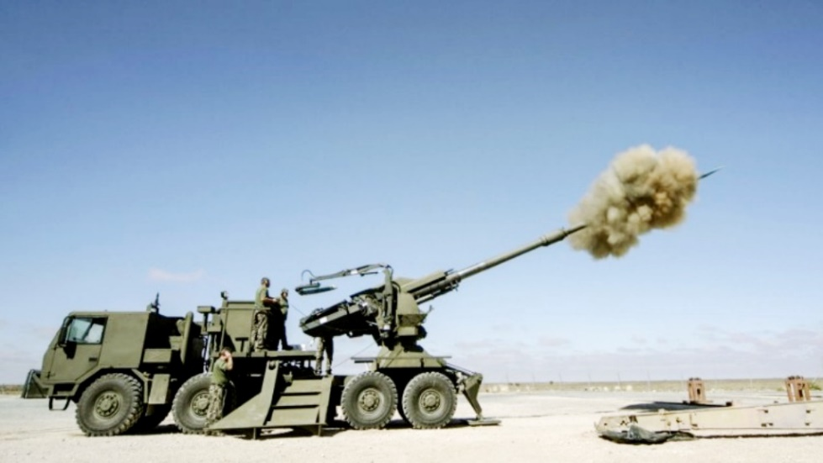

TATA 155 MM Howitzer

Here is link for TATA 155 MM Howitzer. (<http://trishul-trident.blogspot.com/2012/12/which-one-should-it-be.html>)

## Specification of TATA 155 MM Howitzer

|  |  |
| --- | --- |
| Year | 2010 |
| Total Crew | 4 |
| Length | 32 feet |
| Width | 9 feet |
| Height | 11 feet |
| Speed | 85 Kmh |
| Engine | Diesel 6-Cylinder 1200 HP |

## Comparing Both Tank

K9 Thunder is design with chin and 8 cylinder. TATA is 6 cylinder engine. Bothe of the engine sound are not different. But the speed of the engine is different. K- 9 thunder is slower than TATA. Because the torrent in K-9 is big and the weight of the torrent. But it can take out in every condition. It doesn’t need to know the ground clearance because the chain can geo in mud, sand even it is heavy. Chain can push sand and made away. It use modern technology to fire the cannon. The torrent can turn only 180 degree because it can vibrate and turn down tank because of shooting and it doesn’t have ground holder. But it can prevent from sniper and refile shooting.

TATA’s howitzer is different. It use 8 wheel drive. Because of the wheel it is fast. It can vibrate so it has ground holder in tank. So it can less vibrate than K-9 Thunder. Unlike K-9 Thunder it can shoot six HE (High Explosive) ammo one time. K-9 thunder can only shoot three in one time because of its space. TATA space is wide because the cannon is outside and control by both computer and human. It has bullet proof glass in the head of truck but the cannon is clear, so enemy can see easily. Unlike K-9 Thunder, it need ground clearance to put ground holder. It took a minute which was control by computer.

Both tank use 155 MM and 52 MM sub machine gun. And the shooting range is same. But it different design, and their interfaces. Both tank can carry 4 crew. And K-9 Thunder can stand by itself but TATA howitzer need ground army to protect it. So this is the compares of Samsung Tank and TATA howitzer. I hope you will understand about their performances.

-------------------------------------------------------------------------------------------------------

# D 1

# Preparation & Problems

I think about a tank for the assignment and I have to design and implement about the project in assignment 2. So in assignment I have to evaluation, their safety, economy, and ergonomics and so on. So I got the idea from an animation. An animation is also include tank. That tank is not same with nowadays. It tank is small and very powerful. I got the idea form that animation. It is not exactly. I draw it before the assignment is coming out. Because assignment 2 is to draw design which I choose. After I know about how to design and draw I choose a tank for HCI assignment. And before it doesn’t exact teacher asked all class think about the project for the assignment. Some student already told to teacher. But I told, some of the student are laugh me because data is not confirm and teacher doesn’t notice that. So teacher asked data to us by one. My turn teacher and some of the student surprise. Really really. And they asked to me. I says yes and I give the tank project to teacher. Preparation doesn’t make me any difference. it is only for design for the assignment. Before assignment hang out. I really don’t know about the outcomes.

After giving data to teacher, teacher give us some exercises to do before assignment and she also want to accept email before 12:00 PM of Tuesday. That homework is given on that Friday. Unfortunately, on Saturday, I caught a cold and a virus appear called dengue fever. And the illness is still on Tuesday. So I can’t do homework and I didn’t send email to teacher. On Tuesday, teacher give another homework and send it before 12:00 PM Saturday night. I also absent that homework and on Wednesday, the illness is not better so I stayed at hospital for three days. On Saturday, evening I come back to my home. And I missed all homework and second homework is when I open internet, it was already posted in our HND 20 group. And I was surprised and I decided not to do. Because I don’t know what to do. I just prepare for design and doesn’t think about assignment 1.

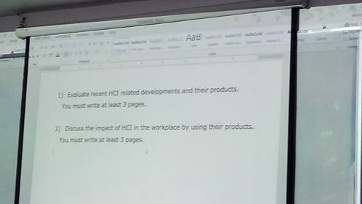 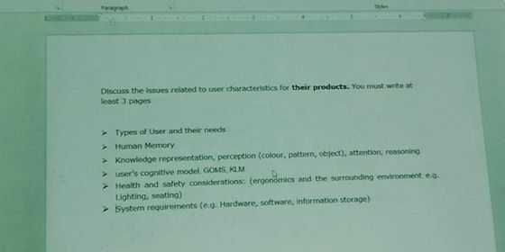

Task 1 and Task 2 are given as homework before assignment hangout

# Research & Problems

On Sunday, the day after that I stayed at hospital and com back home. I don’t have nothing to do at home. So I decided to do HCI homework. So I started task 1 which is given when I attended. The heading is the evaluation of a product. So for me, a tank. I met the problem at first. Actually I don’t know about tank and I really realize that point is in assignment. I only think about the function and requirement. So I found about tanks that was release by years and famous tanks for the past. It take three hours to find it. and I really don’t know about tank. And it is difficult to find the famous tank. But luck is on my side. A site is finally found which is combine all tanks which is realeased by year and they told the famus tank of the year. But a problem is their explanation is too long. So I just copy some of the infromation. So if finsish a part of the task 1. But the result is bad when I upload in turnitin. All the information that I copy is match with that website.

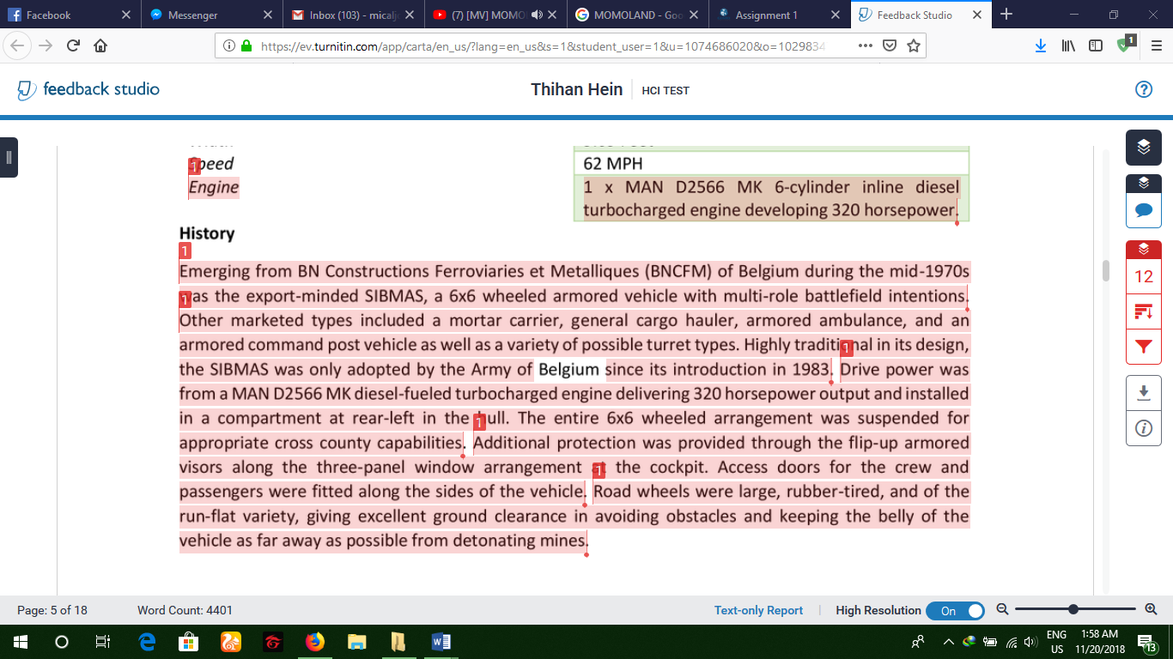

It was known after I finish that task. I really susprise for turnitin. They can also check with military website. I was same as one of Myanmar speech “Mi Aye hurts twice”. I fix that and I read their information carefully and write by own tune. It take also time to fix. Actuall also second point of task 1 I also met with problem. Tank doesn’t use in society and ethnic. If I says the unwanted information like for the battle it is not related with society. So I made a decision to write about work place and economy of the tank. So lack is still on my side. There are many place that use in work place for tank. I know it because my father work in military and like bomb finding. Emergancy bridge construction and so on. I asked hime and write about them. And it is just easy for me.

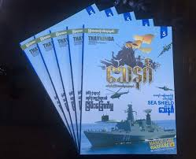

That book is tell about some tanks and their information. And I read some information and copy from Myanmar to English. That book is really help for me to finish second part of task1. I finished task 1 on Monday and I continued to do task 2. But I doesn’t send email because the deadline is over.

For the task 2 some of the parts are easy for me because I already think about the parts, like ergonomics, types of user and their requirement of a tank. I only faced problem with GOMS/ KLM and knowledge representation. It is hard to relate with tanks. But I find ways to join with tank for the knowledge representation. For the GOMS and KLM I only skipped to make sure with teacher. I finished all task 2 on Monday night. On Tuesday I show it to teacher I agree with for GOMS/KLM and check the other parts and get agree with teacher.

After 2 weeks later, the review session come of HCI. At that time I only finished only pass point. I didn’t finish merit and distinctions points. At that night, I tried to finish M1 point and M2 of assignment 1. But I only finished M1. Because I feel tired. On Wednesday morning, I continue for merit 2. That was also difficult for me. I don’t know which private company produce tanks. So I find to write about that. it takes about an hour to get two company. Finally I found two company. Another problem is I don’t know which type of those two company produce. So it take an hour to get the answer. After I found answer, I do M2 point harder.

# Learnt form Research

Actually I really don’t know about tank. For the assignment I just want to make difference and thought about the design. I don’t realize about their evaluation and their working place. All people think including me thought tank is only used for battle. But after reading some facts I realize they also used to use in rescues and for the economy. In economy, tanks are very useful for selling other countries and their related accessories like ammos, armor and so many things. I know the inside material of tanks. And the inside interface of the tank. Only military man know the interface. For the public it is hard to see and most of the function are does not display on the website. Because it is secret to the terrorists. But I didn’t give up and I read book of tanks who is observing in military.

During assignment, I realize about the infrastructure of tanks. And I know there are many types of tanks. And I knew about the company that produce military product for the military. Not only Samsung, TATA. Other company Mitsubishi, Toshiba and other private also product tanks for military for their political and economics. There are very tricky about both political and economics. And for the Heuristics Principle I realize that is there any point that apply Heuristics law. Actually at that time I haven’t read that law. After reading law I know some part that accept Heuristics law.

Finally I finish all points of assignment one. I learnt new things about tanks and I found many problem and I give up nothing for the assignment.

-------------------------------------------------------------------------------------------------------

# D 2

# Time Schedule

Here is time schedule that I tried out before dead line. And I had some problem at that time because I caught a cold and other problems. But I can finish all task in time even though I have problems.

|  |  |  |
| --- | --- | --- |
| No | Date | Description |
| 1 | October 10 2018 | October 10 was not an assignment hang out date. It was a date that teacher give us to homework. And also emailed to her before 12:00 PM of Tuesday. Unfortunately I caught a cold and stay in hospital I did finish and email it. |
| 2 | October 12 2018 – October 14 2018 | Those days are I was in hospital because of dengue fever. |
| 3 | October 15 2018 (Evening) | I started HCI homework of evaluation of product that I choose. It take about 5 hours to finish that task. Because I don’t about the tanks. So I research on the Google. |
| 4 | October 15 2018 (After Dinner) | I continue HCI and do first part of the homework the work place of the product. |
| 5 | October 16 (Morning) | I continue HCI and task 2 of the homework which was upload in HND 20 group. I just read and do it on that day. The interface, human memory, knowledge representation, ergonomics and system requirement. Those October 16 morning. I do two point, type of use and human memory and I finished it. |
| 6 | October 16 (Evening) | After having lunch, I continue other points, human memory and knowledge representation. It doesn’t take much time it take about two hours to finish. After that I take rest. I played game |
| 7 | October 16 (Night) | After having dinner, I continue the rest point. GOMS/ KLM are difficult for me. So I skip and continue other point. It take three hours to finish. After I |
| 8 | October 17 (HCI subject time) | I show to HCI teacher to get the agreement for tasks and GOMS/KLM. |
| 9 | November 11 2018 | I started Merit point. It take three hours to finish for the Heuristics law and to connect with project. Because I have to read detail of Heuristics law to connect with project. |
| 10 | November 17 2018 | Merit 2 is done in that day. It take three to finish because it tell about the different design of the different company of my product. So I research for tanks that produce by private company. After I found I do it harder to finish. |
| 11 | November 19 201 | Distention 1 is done in that day. And it take an hour to finish. I think about tasks that I did in past and write about it. |
| 12 | November 20 2018 | Distention 2 is done that day. The schedule for the assignment. And I talk about some problems with time. On November 20 I done my assignment and ready to upload to turnitin. |

Most of the tasks are I found in Google. And I read a book which is produced by Myanmar that book is display in D 1 point. I give much time to finish assignment because of my tank product. It is difficult to find and it can’t be lie writing to teacher. Because teacher can notice easily. Tank is not very nearly to teacher. But she can easily know that I lie to her. So I careful for researching and saving references links to evidence to teacher. So I hope teacher will satisfy my trying.

**********Thank You **********

------------------------------------------------------------------------------------------------------------------------------------------

# References Links

<https://searchsoftwarequality.techtarget.com/definition/HCI-human-computer-interaction>

<https://www.interaction-design.org/literature/topics/human-computer-interaction>

<https://en.wikipedia.org/wiki/Command-line_interface>

<https://searchwindowsserver.techtarget.com/definition/command-line-interface-CLI>

<https://er.yuvayana.org/command-line-interface-application-advantages-disadvantages/>

<http://www.itrelease.com/2018/07/advantages-and-disadvantages-of-menu-driven-interface/>

<https://en.wikipedia.org/wiki/Natural-language_user_interface>

<http://www.cpanel.stpaulsscience.org/gceict/specifications/wjec/unit1/technical/hci/natural.htm>

<https://www.pcmag.com/encyclopedia/term/61014/icon-based-interface>

<https://tubikstudio.com/small-elements-big-impact-types-and-functions-of-ui-icons/>

<https://www.nngroup.com/articles/icon-usability/>

<https://www.ergonomics.com.au/what-is-ergonomics/>

<https://link.springer.com/referenceworkentry/10.1007%2F978-1-4419-1428-6_722>

<https://www.ergonomicsblog.uk/human-information-processing/>

<https://www.interaction-design.org/literature/topics/color-theory>

<https://www.techopedia.com/definition/31849/color-theory>

<https://99designs.com/blog/tips/the-7-step-guide-to-understanding-color-theory/>

<https://www.interaction-design.org/literature/book/the-glossary-of-human-computer-interaction/fitts-s-law>

<https://www.techopedia.com/definition/32594/knowledge-representation>

<https://www.learning-theories.com/goms-model-card-moran-and-newell.html>

-----Tanks-----

<https://www.militaryfactory.com/armor/detail.asp?armor_id=94#history>

<http://www.military-today.com/tanks/t72b3.htm>

<https://www.militaryfactory.com/armor/detail.asp?armor_id=692>

[https://www.quora.com/How-are-tanks-used#](https://www.quora.com/How-are-tanks-used)

<https://www.army-technology.com/projects/thunderselfpropelled/>

<https://defenceforumindia.com/tatas-155-mm-howitzer-mounted-gun-system-1072>

<http://www.military-today.com/artillery/t5_52.htm>